- Explore Settings Tab Explore and understand all the options currently available in the Settings tab, including: Multiple browser support Headless execution Retry mechanism
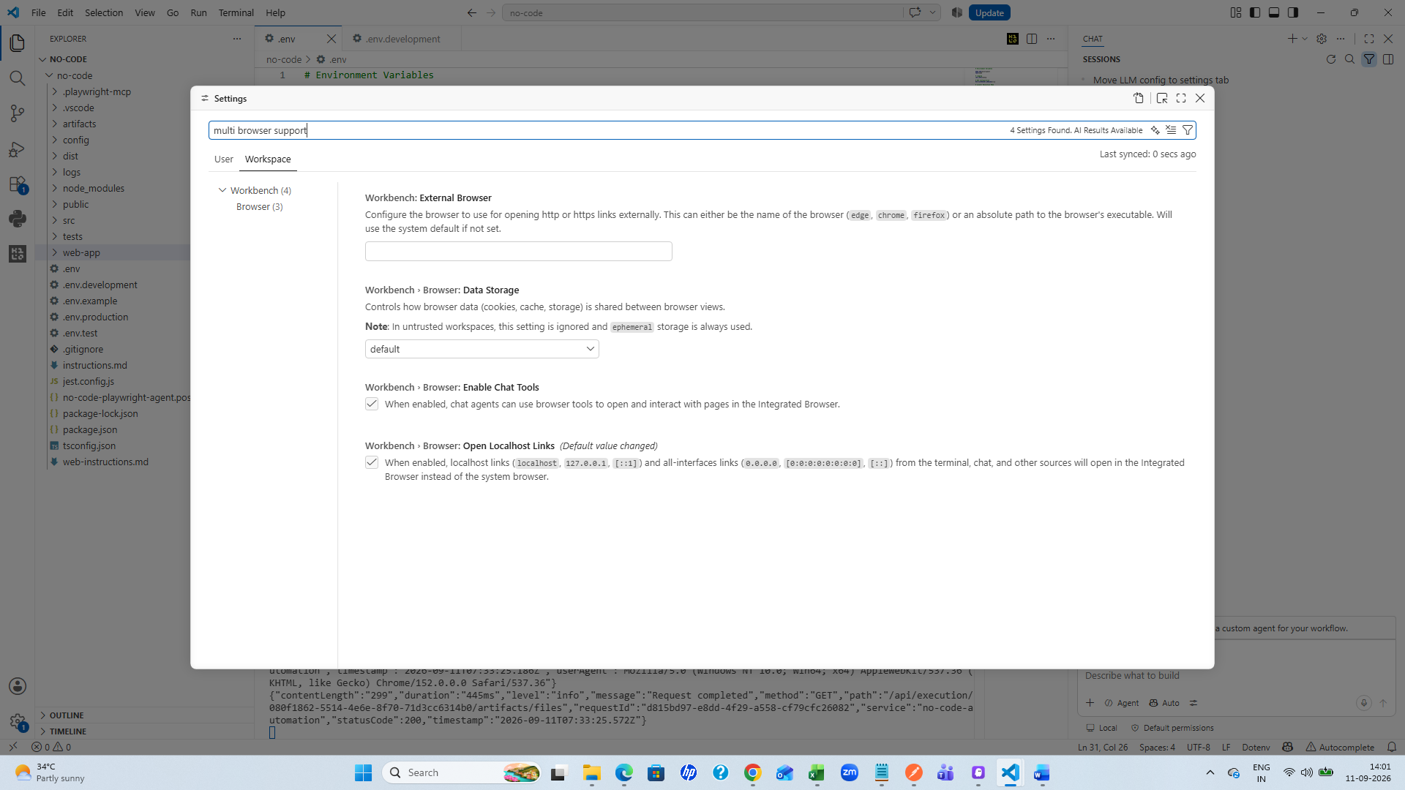

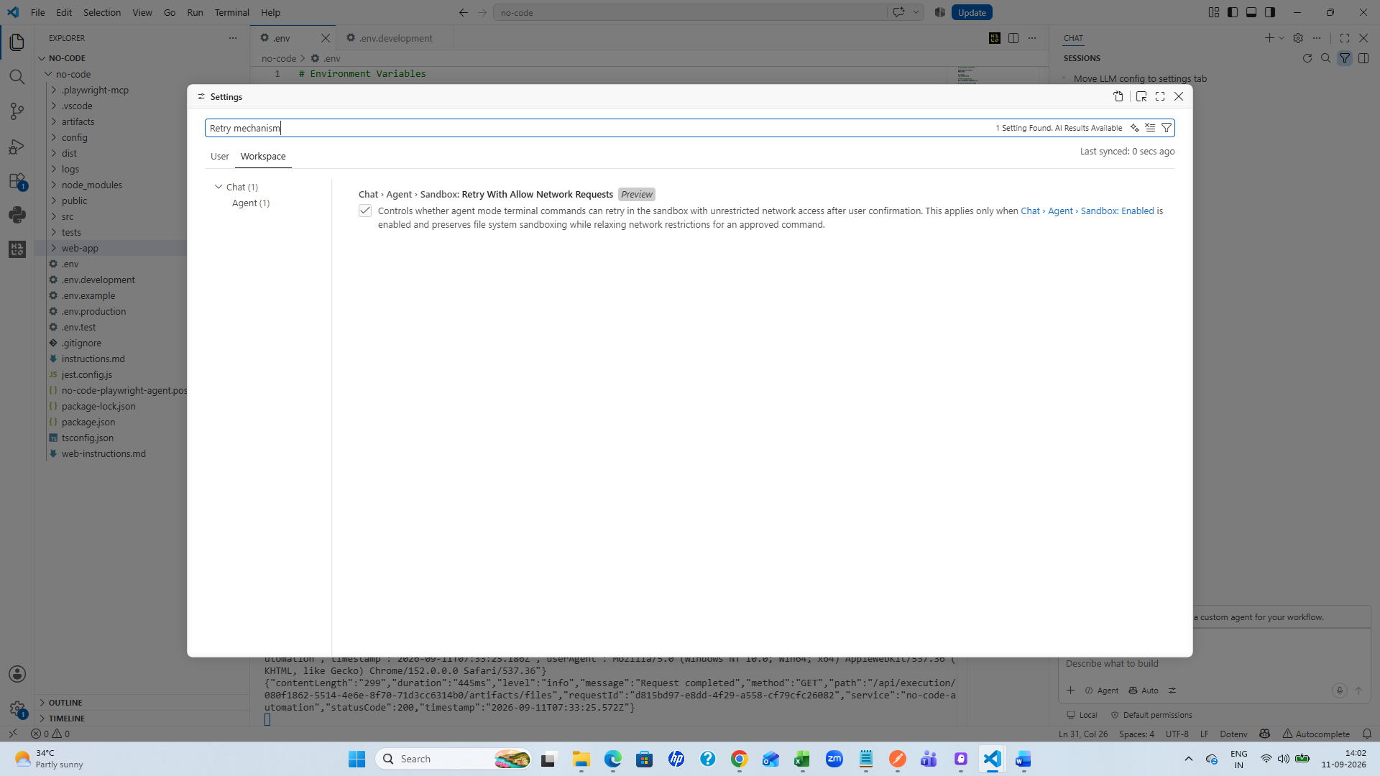

Other settings
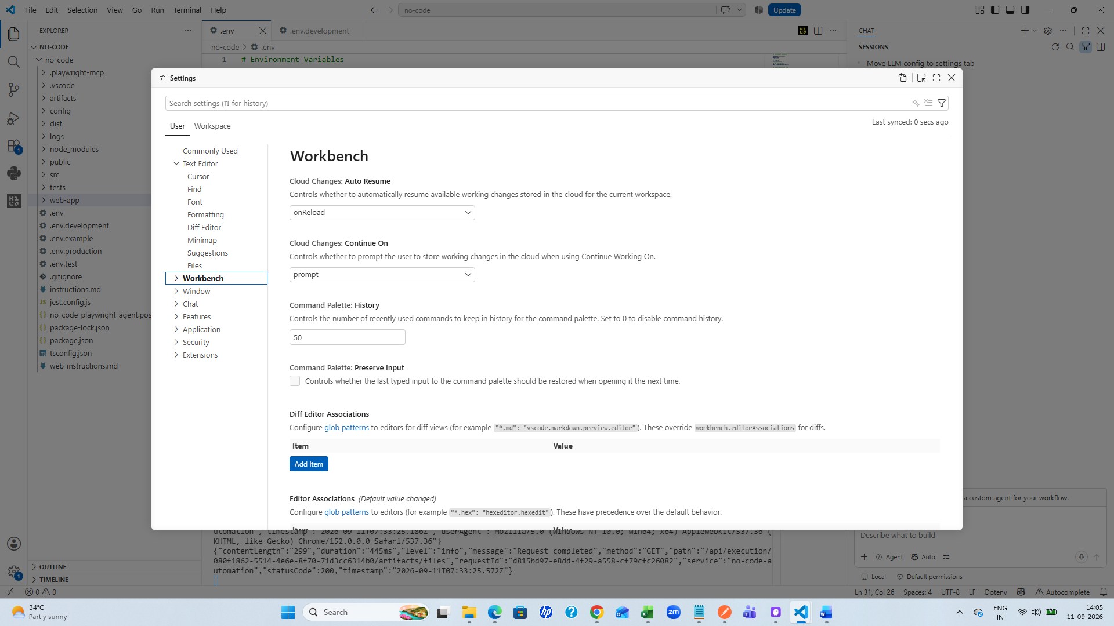

- 2. Implement LLM Configuration in Settings
Currently, the LLM configuration is maintained in the .env file. Move/implement the LLM configuration logic into the Settings tab. A static UI for the LLM configuration is already available in the Settings tab. Replace the existing static UI with the required functional implementation. Ensure that the selected LLM configuration from the Settings tab is used during execution
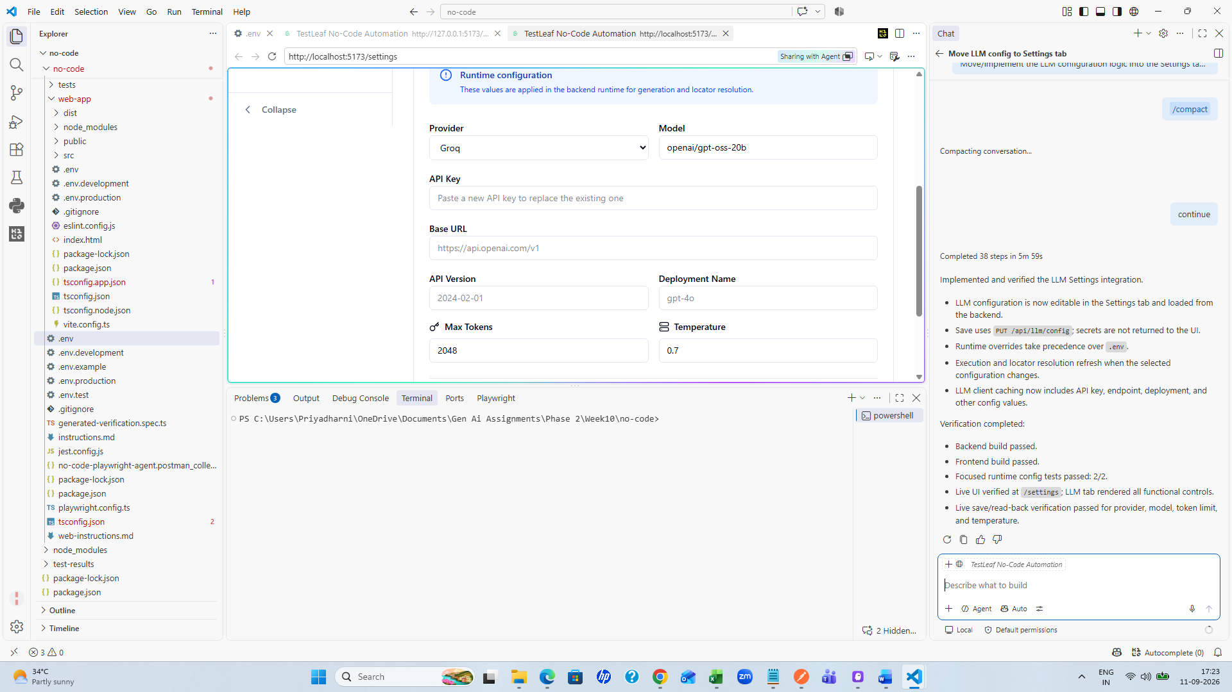
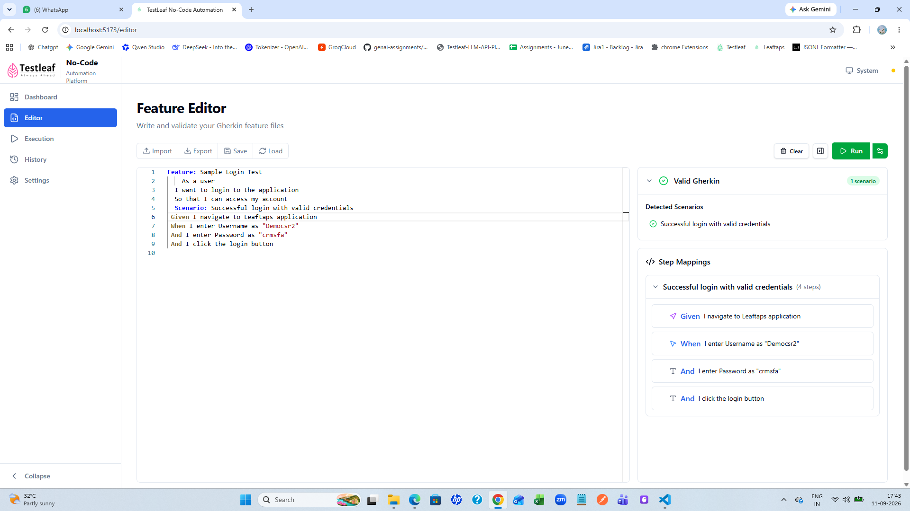
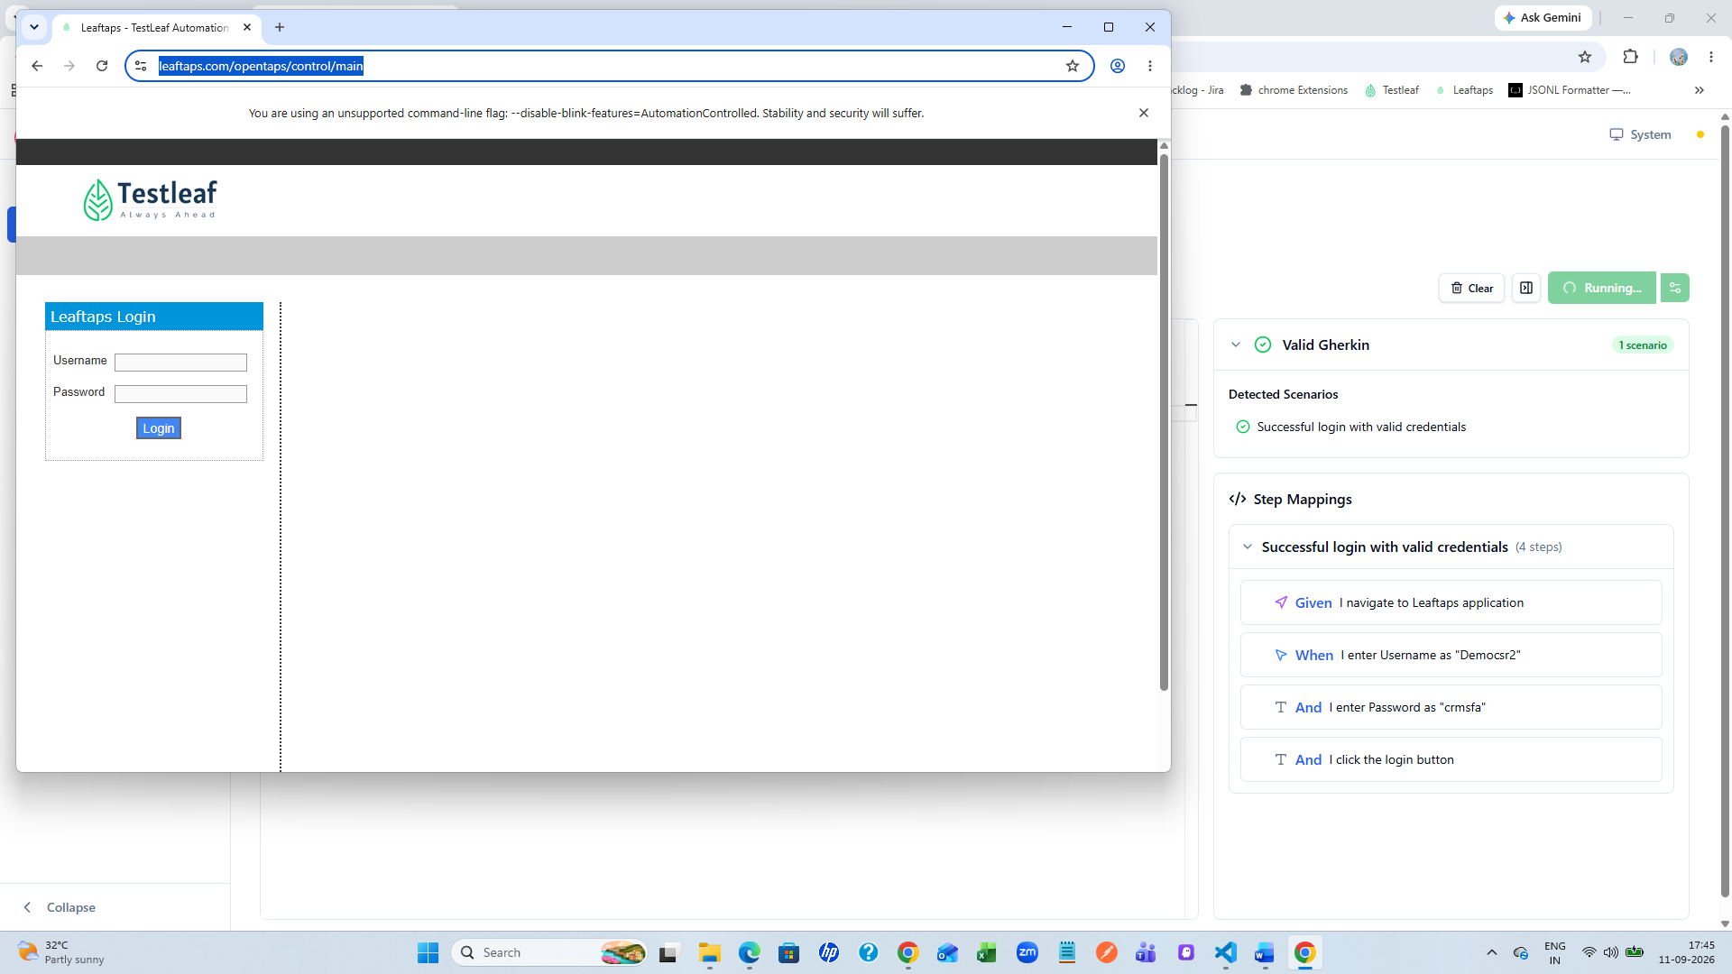
Along with video recording
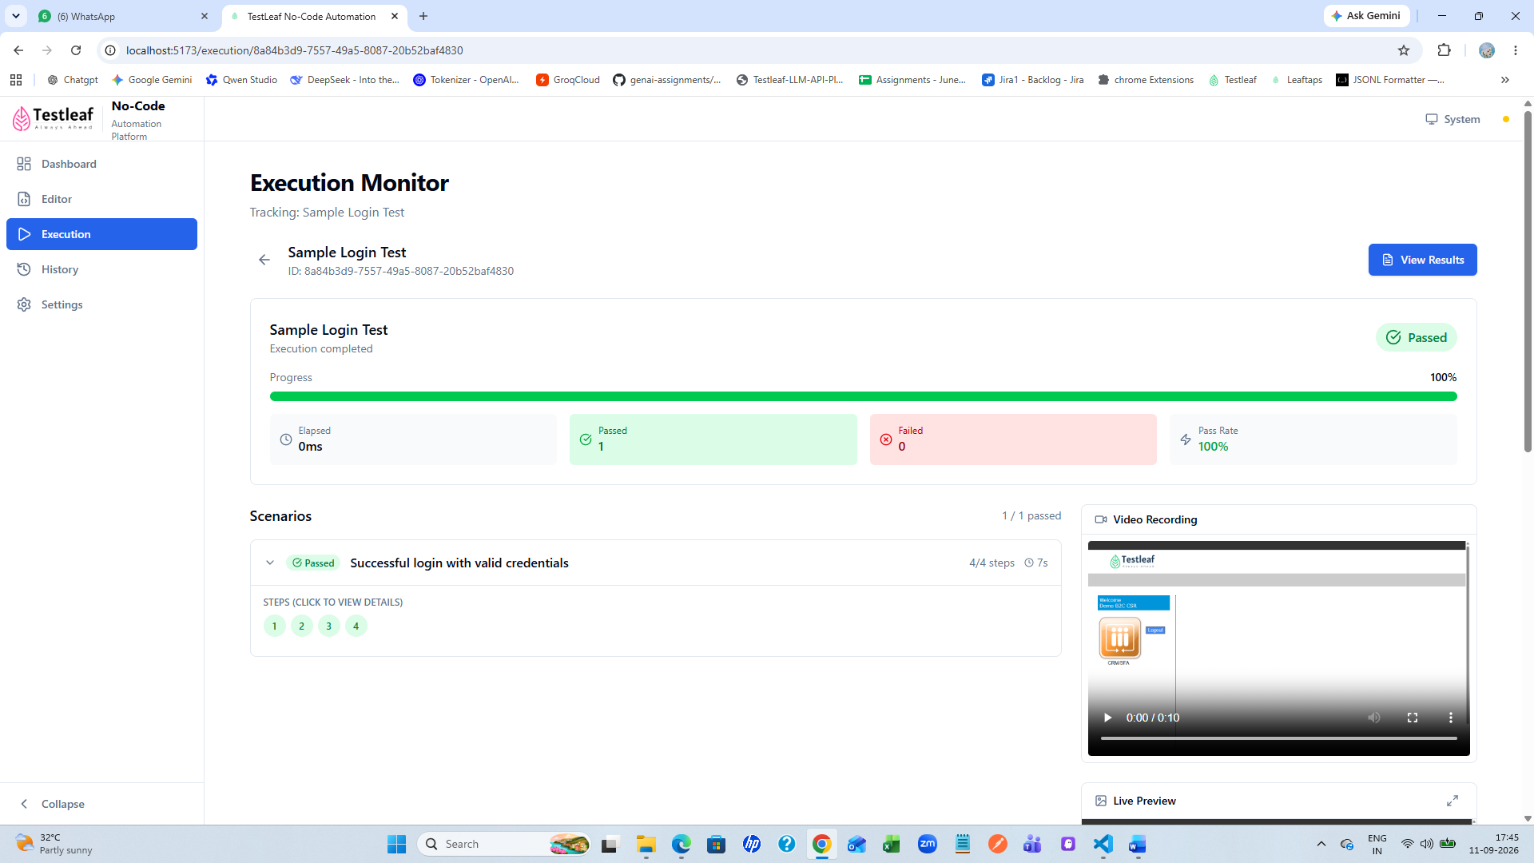
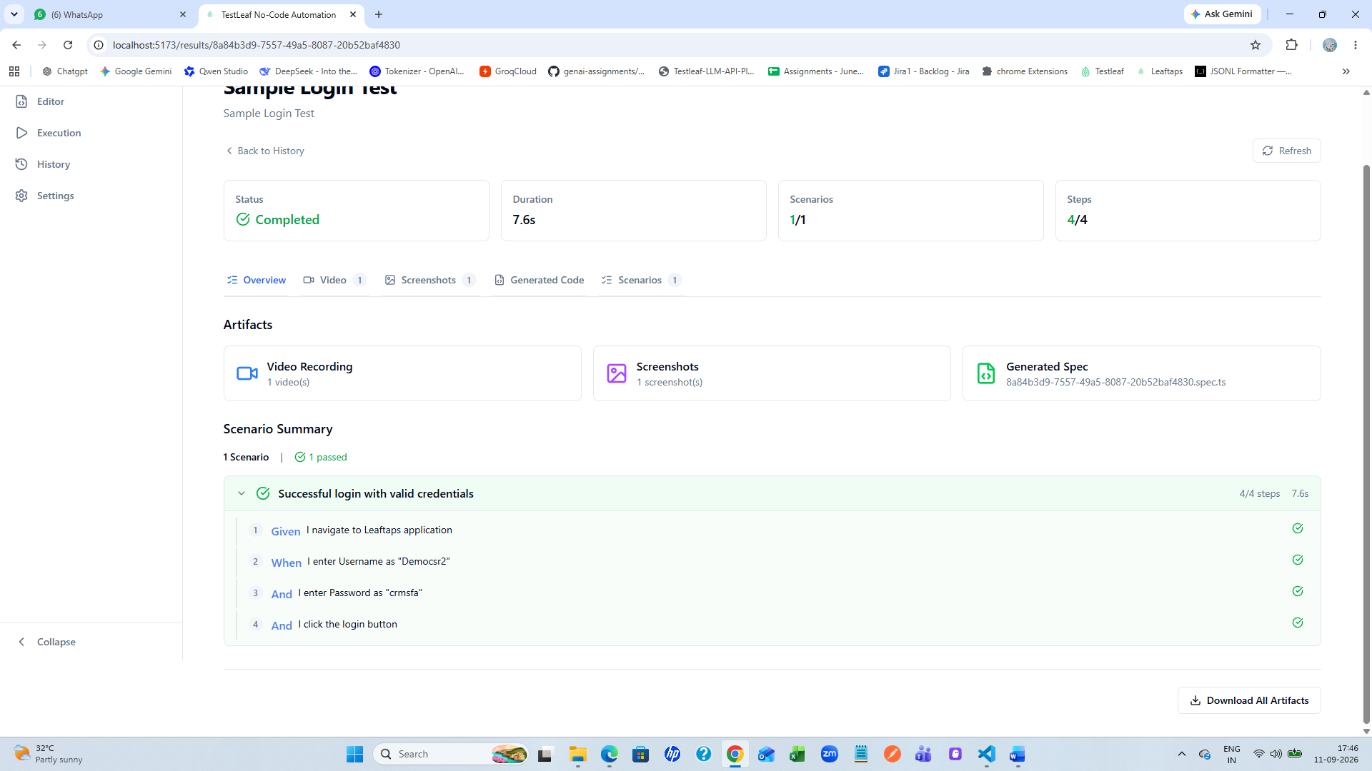
In seetings tab changed the configuration model, temperature, tokensize and saved 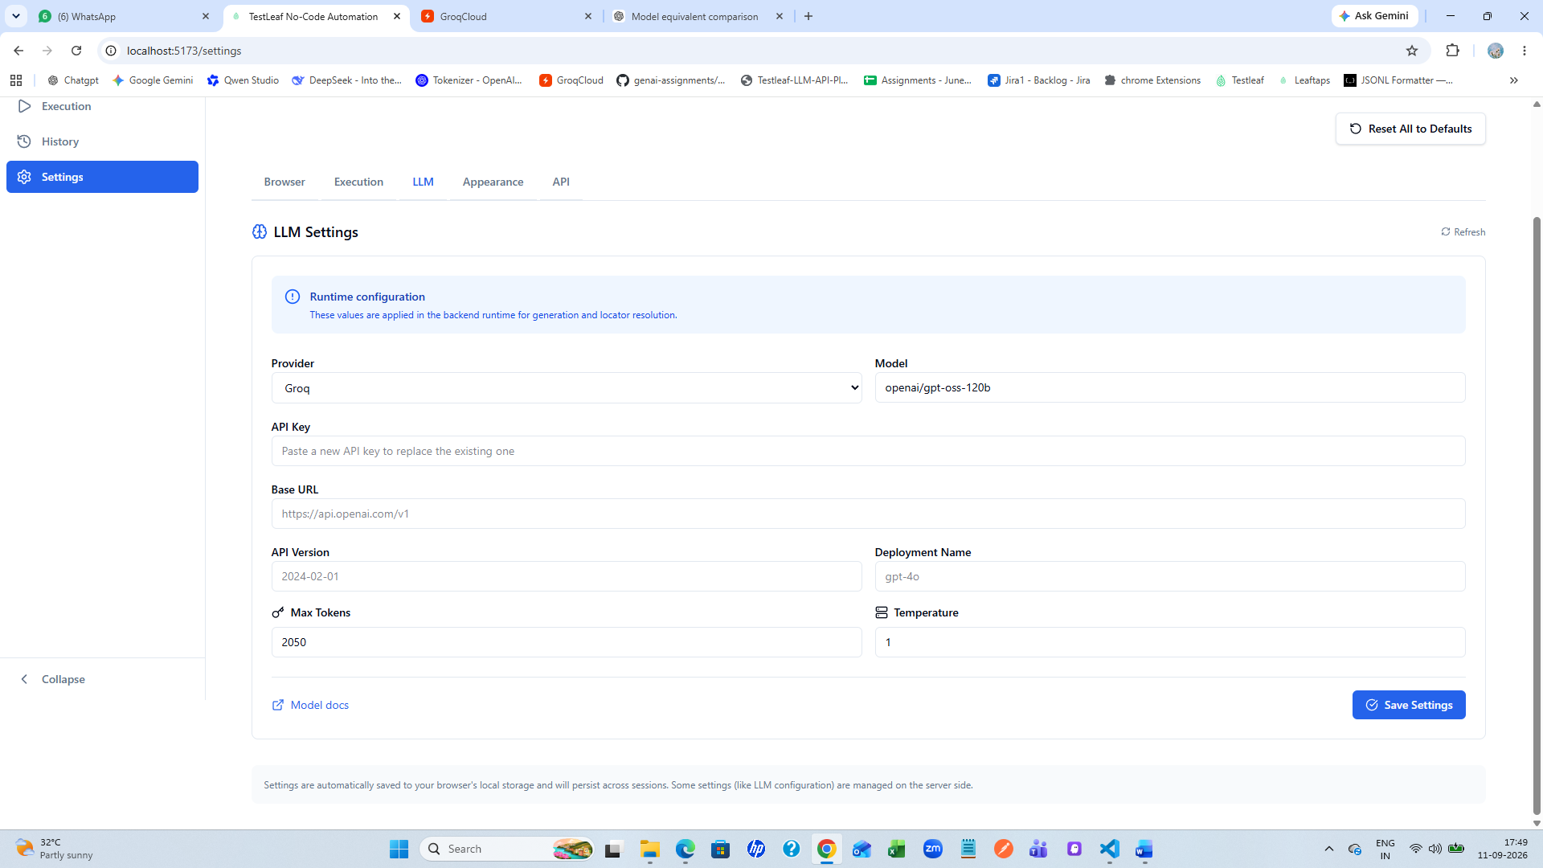
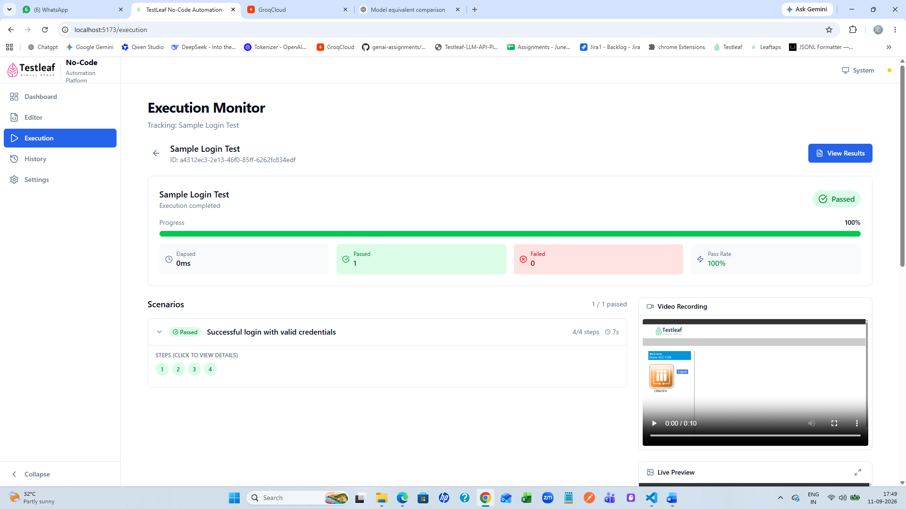
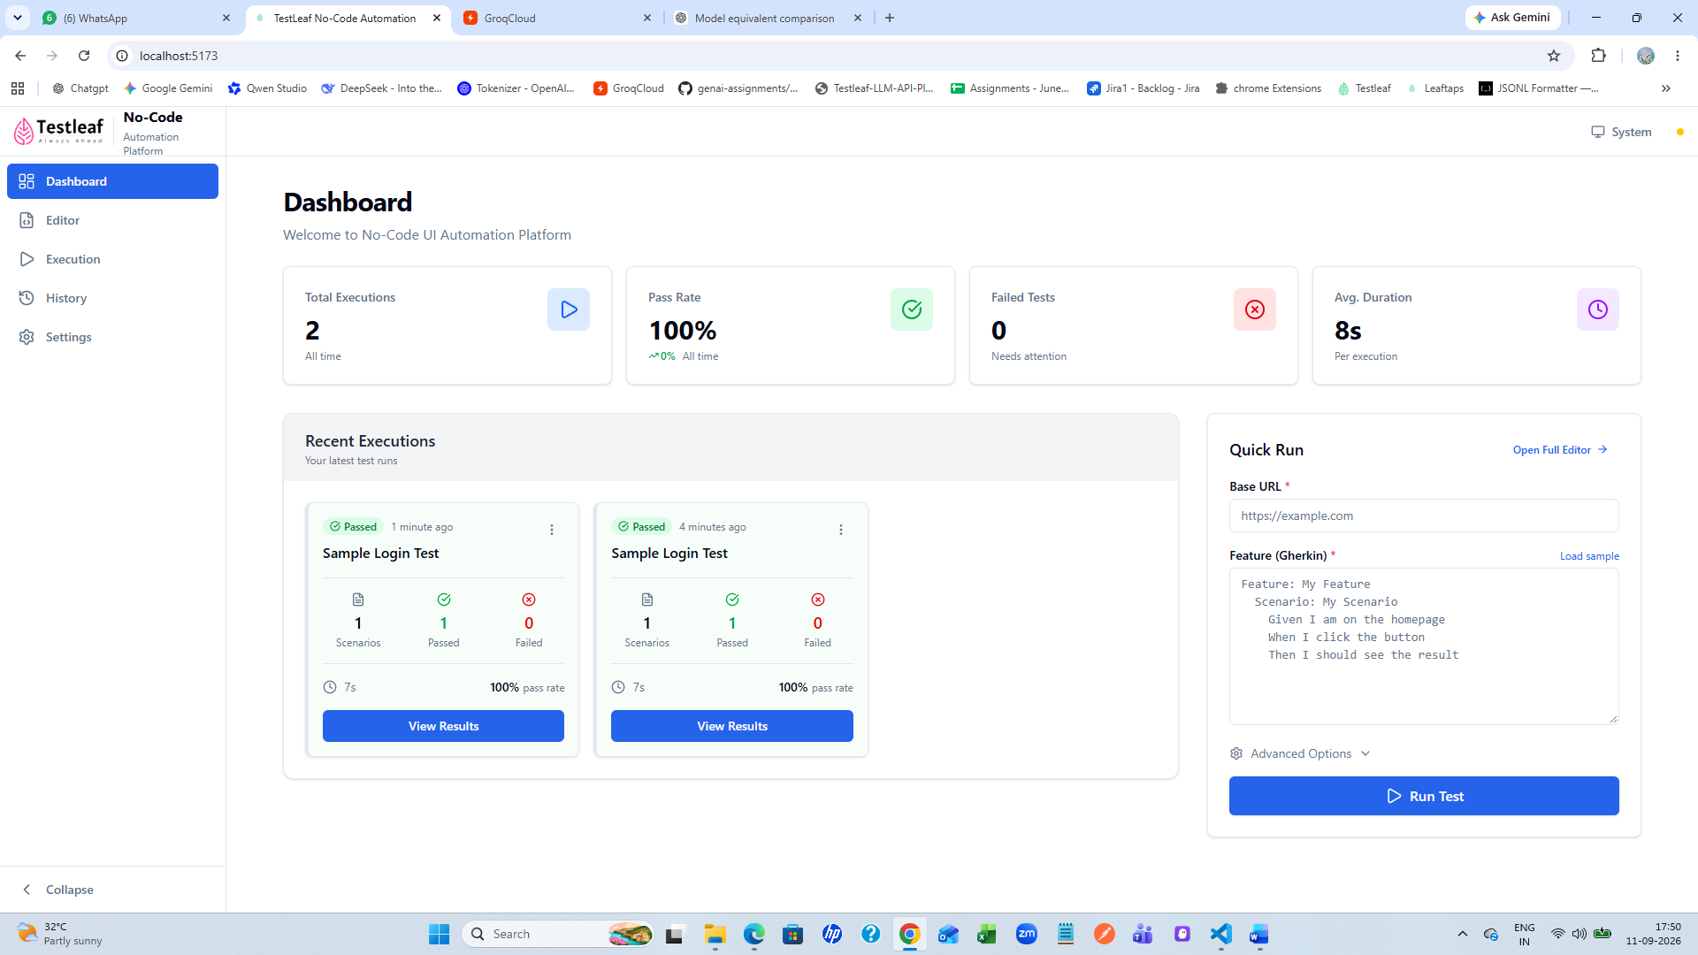
3.Support Plain English as Input
Currently, the Agent accepts a feature file as input, and the MCP launches the browser based on the feature file.
Enhance the application to also accept plain English instructions as input.
For example, instead of providing a feature file, the user should be able to provide instructions such as:
Navigate to the Leaftaps application.
Enter the username "Democsr2".
Enter the password "crmsfa".
Click the Login button.

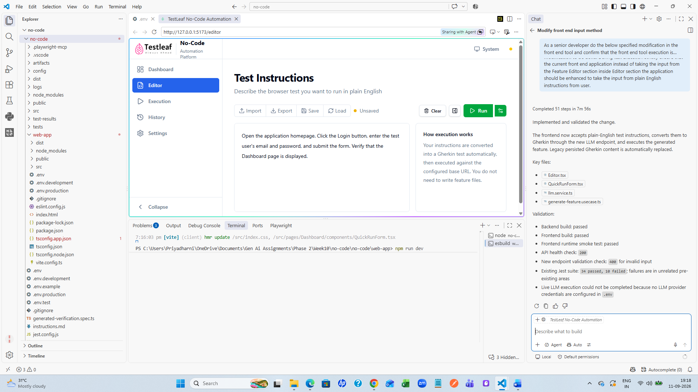
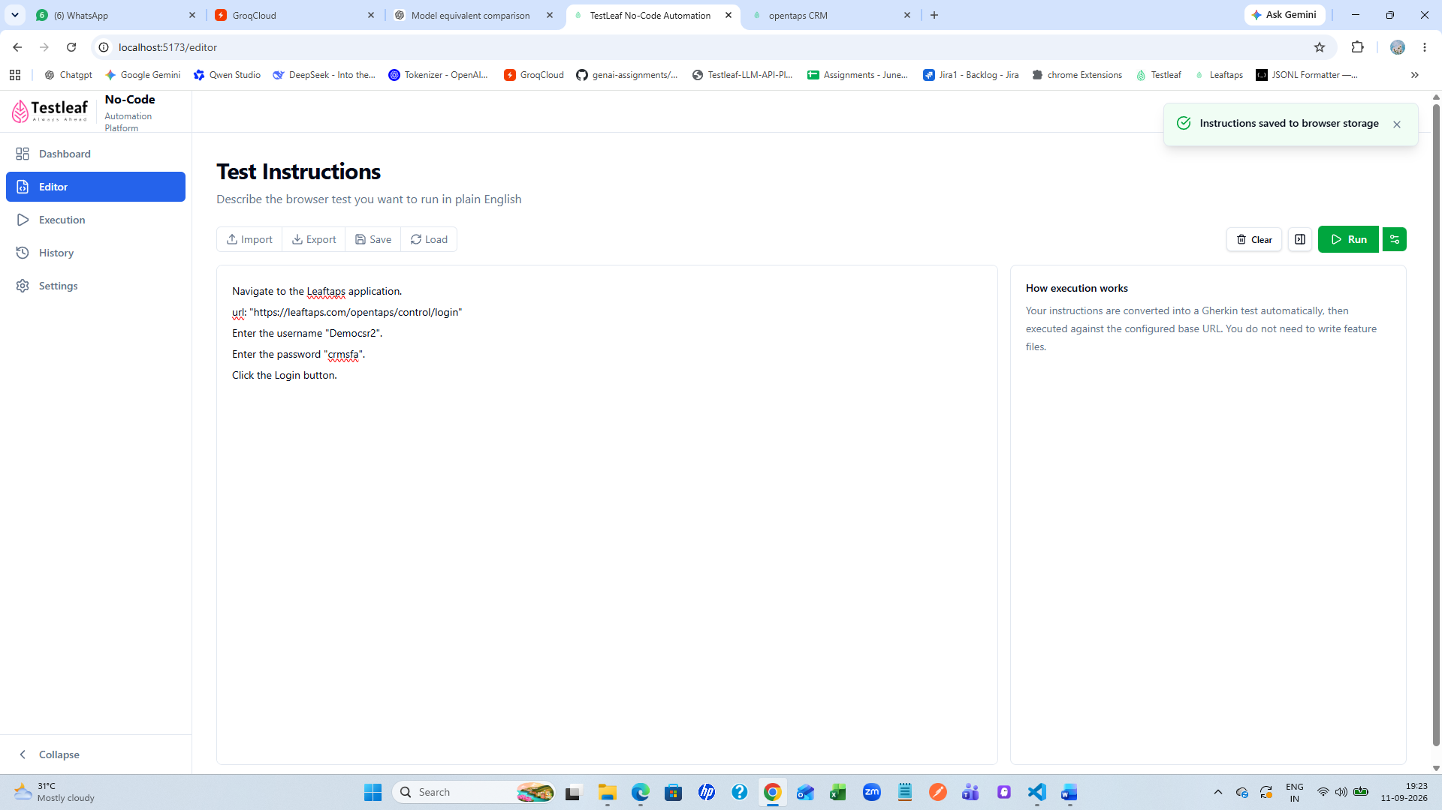
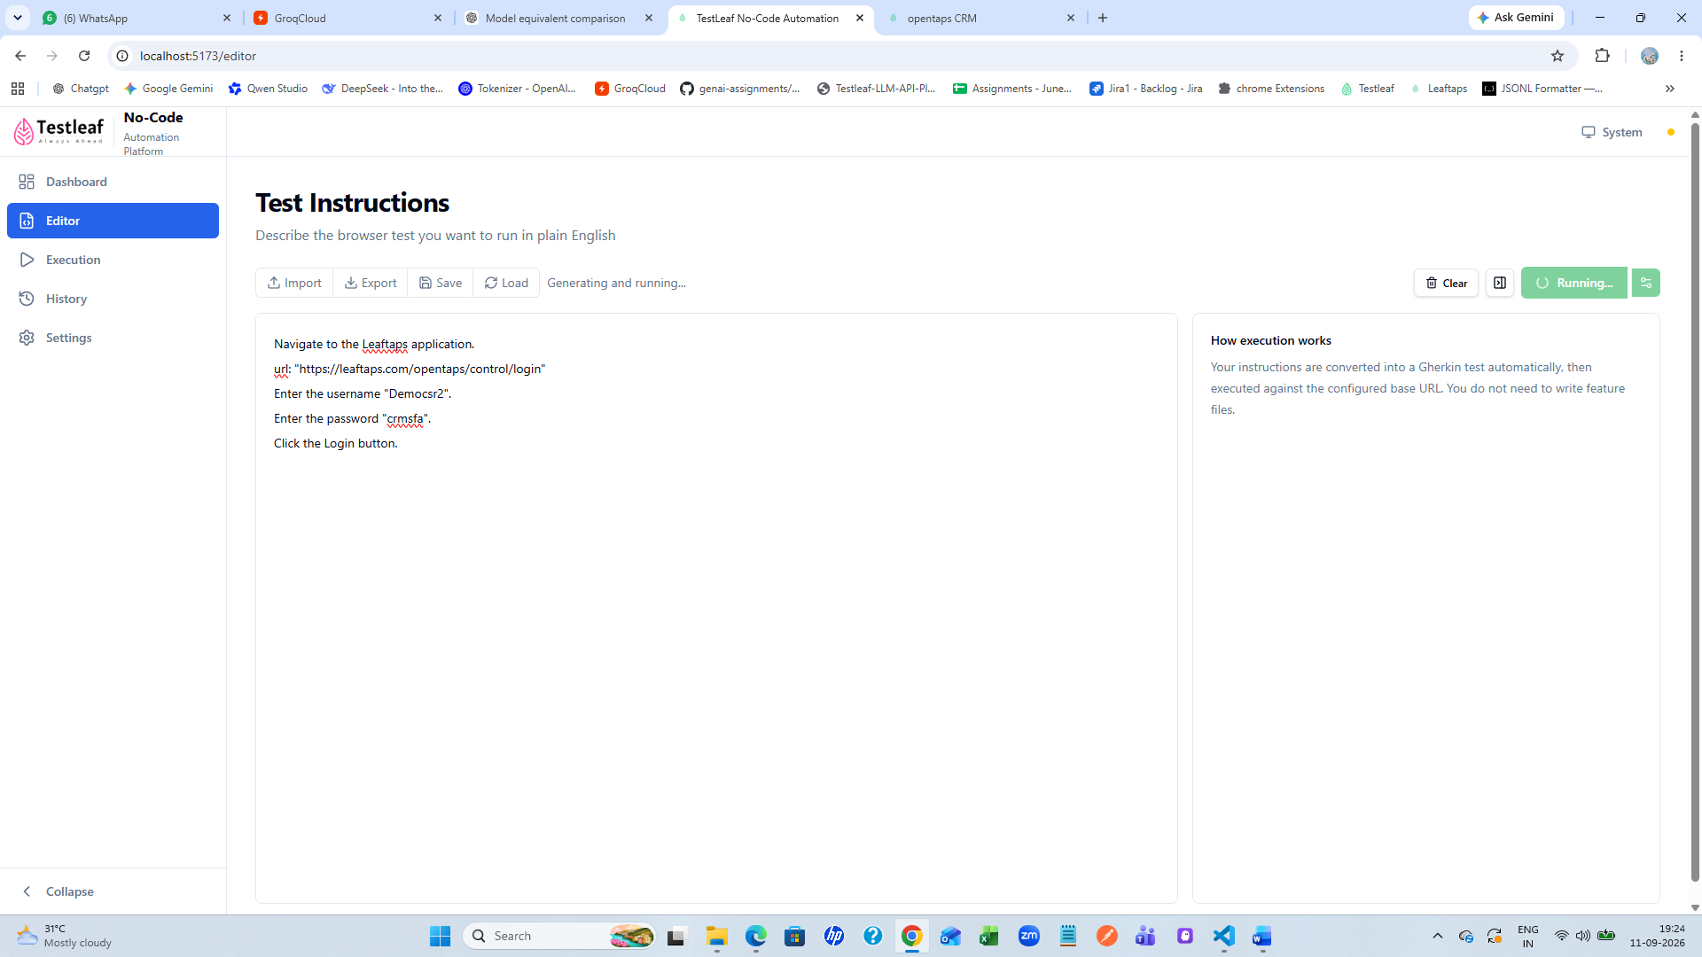
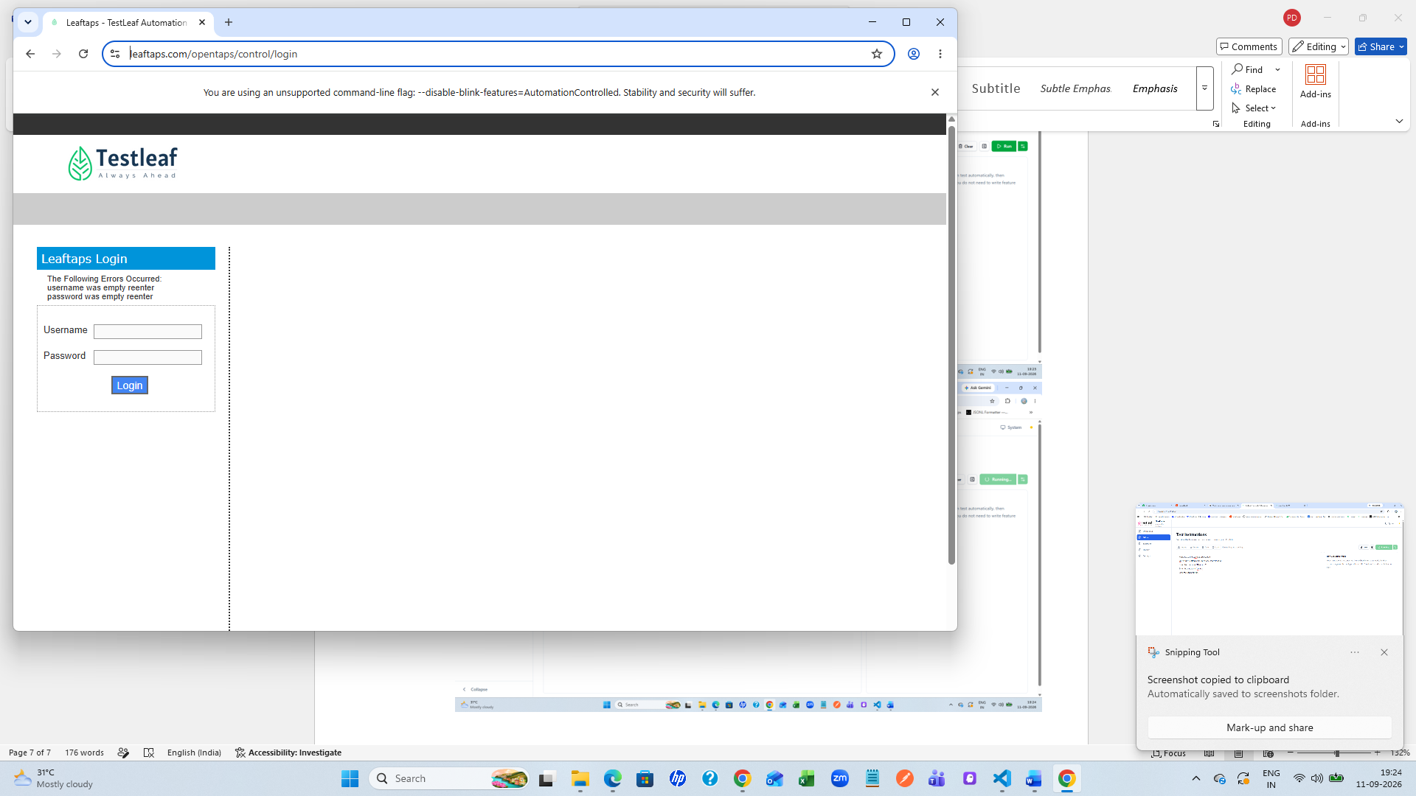

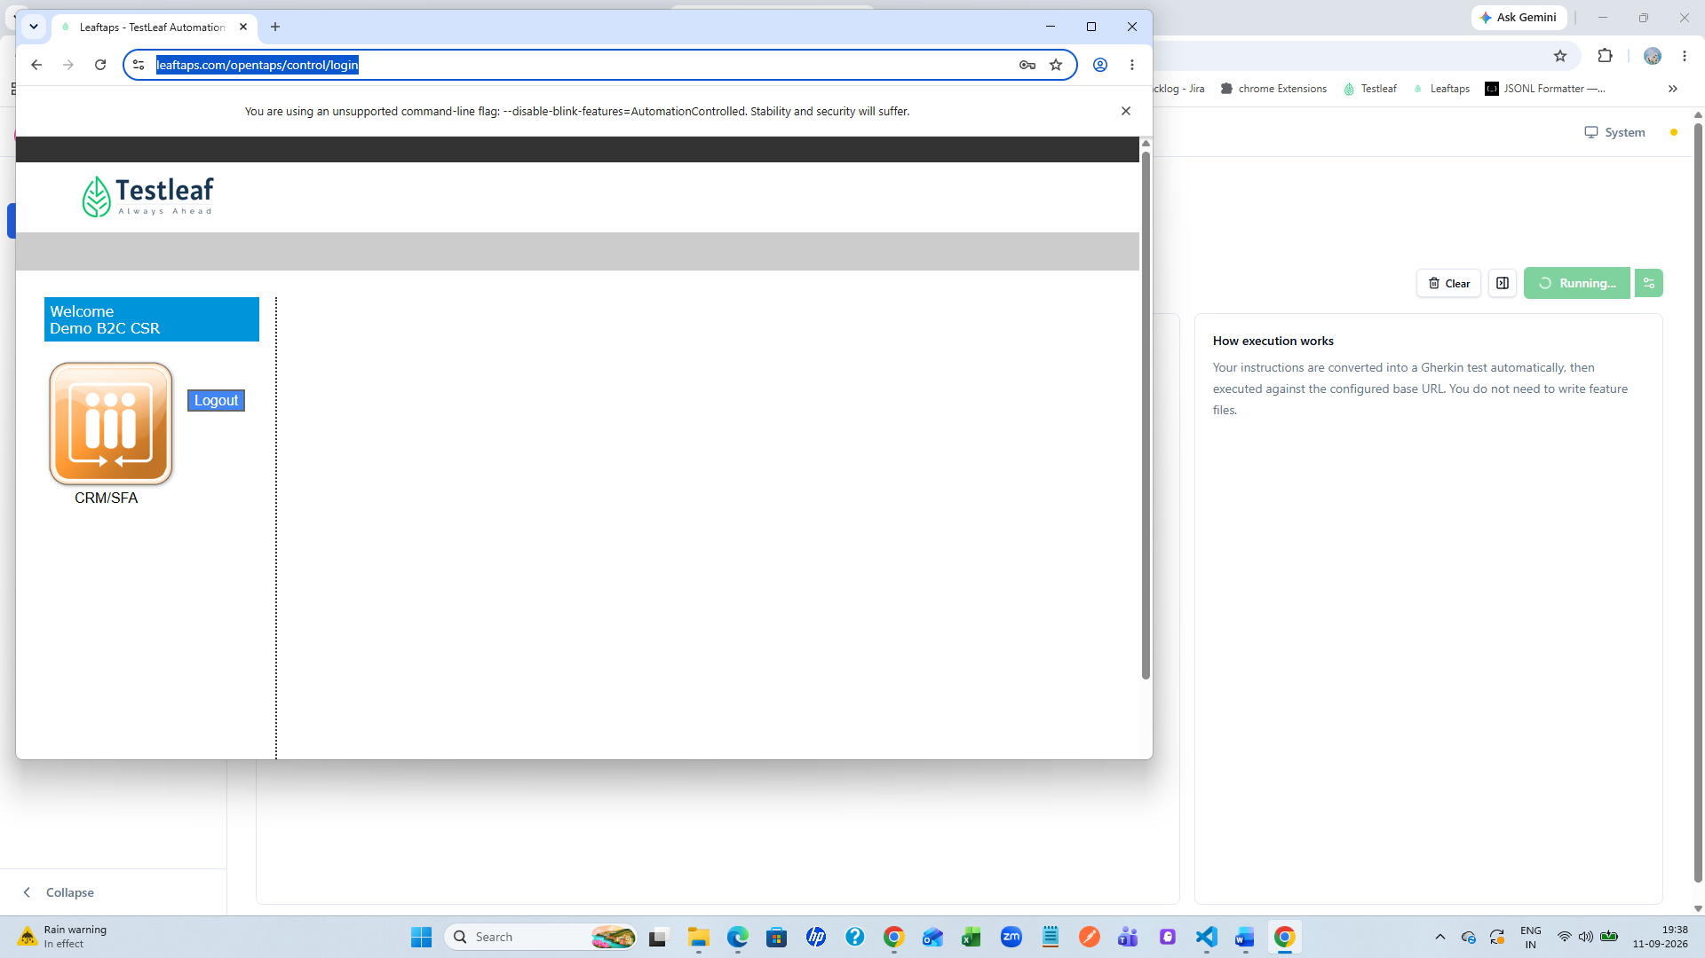
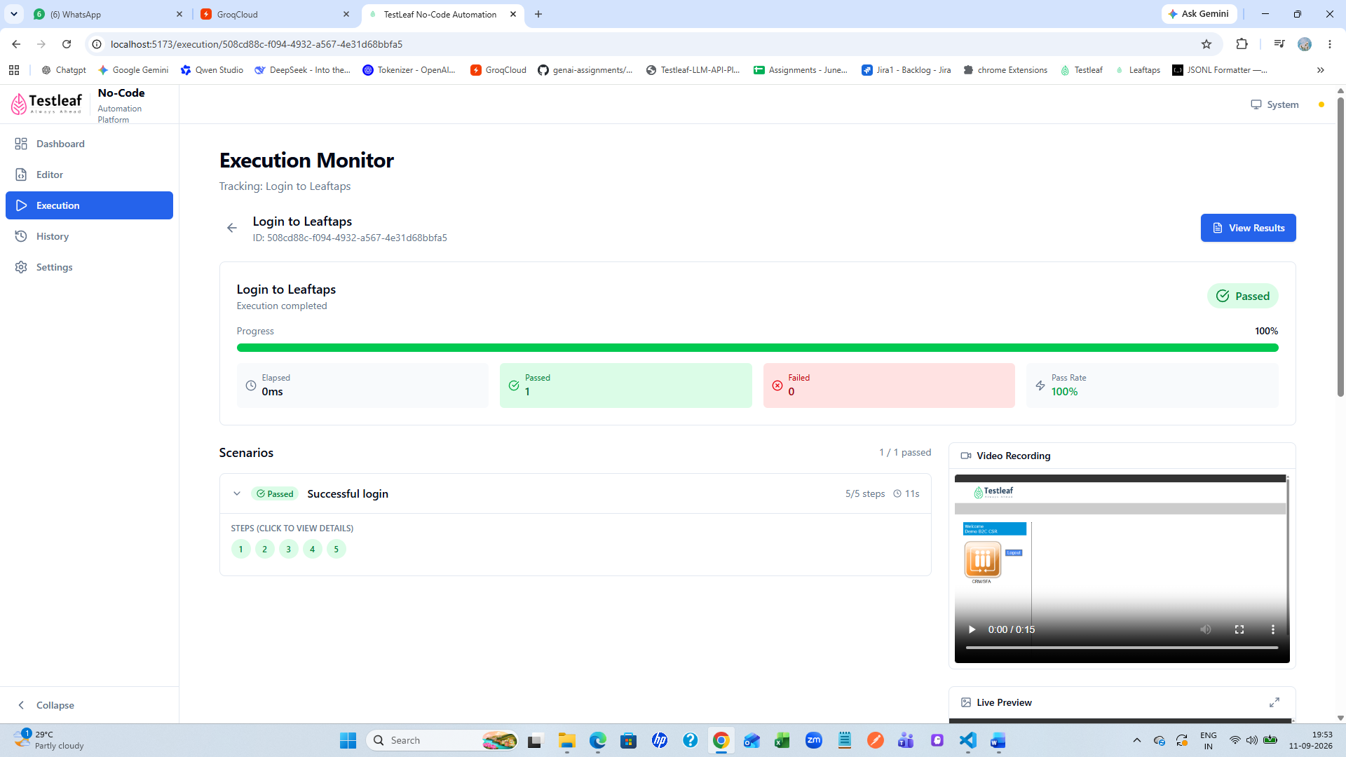
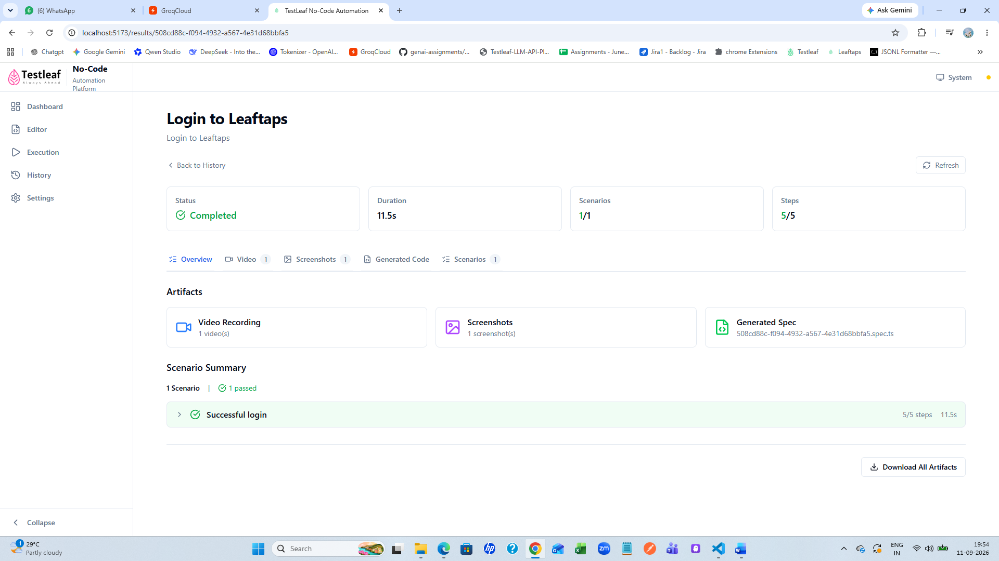
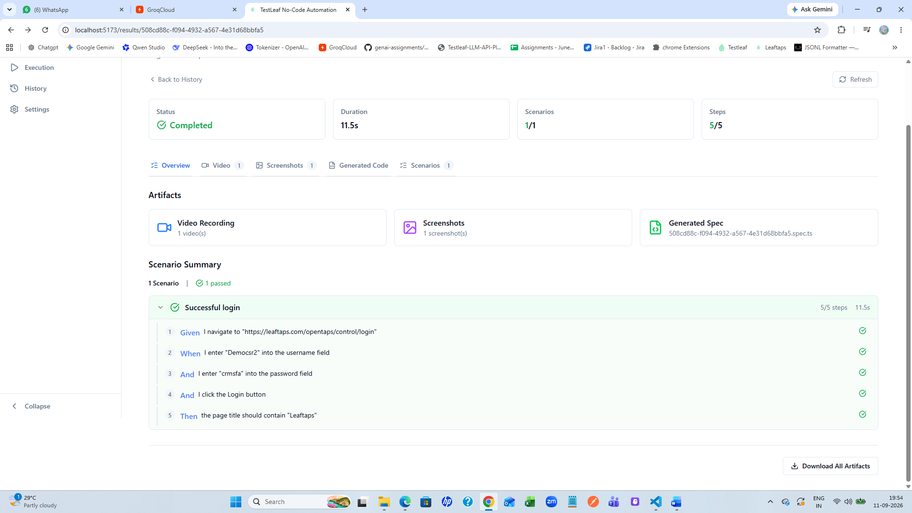
Video recording
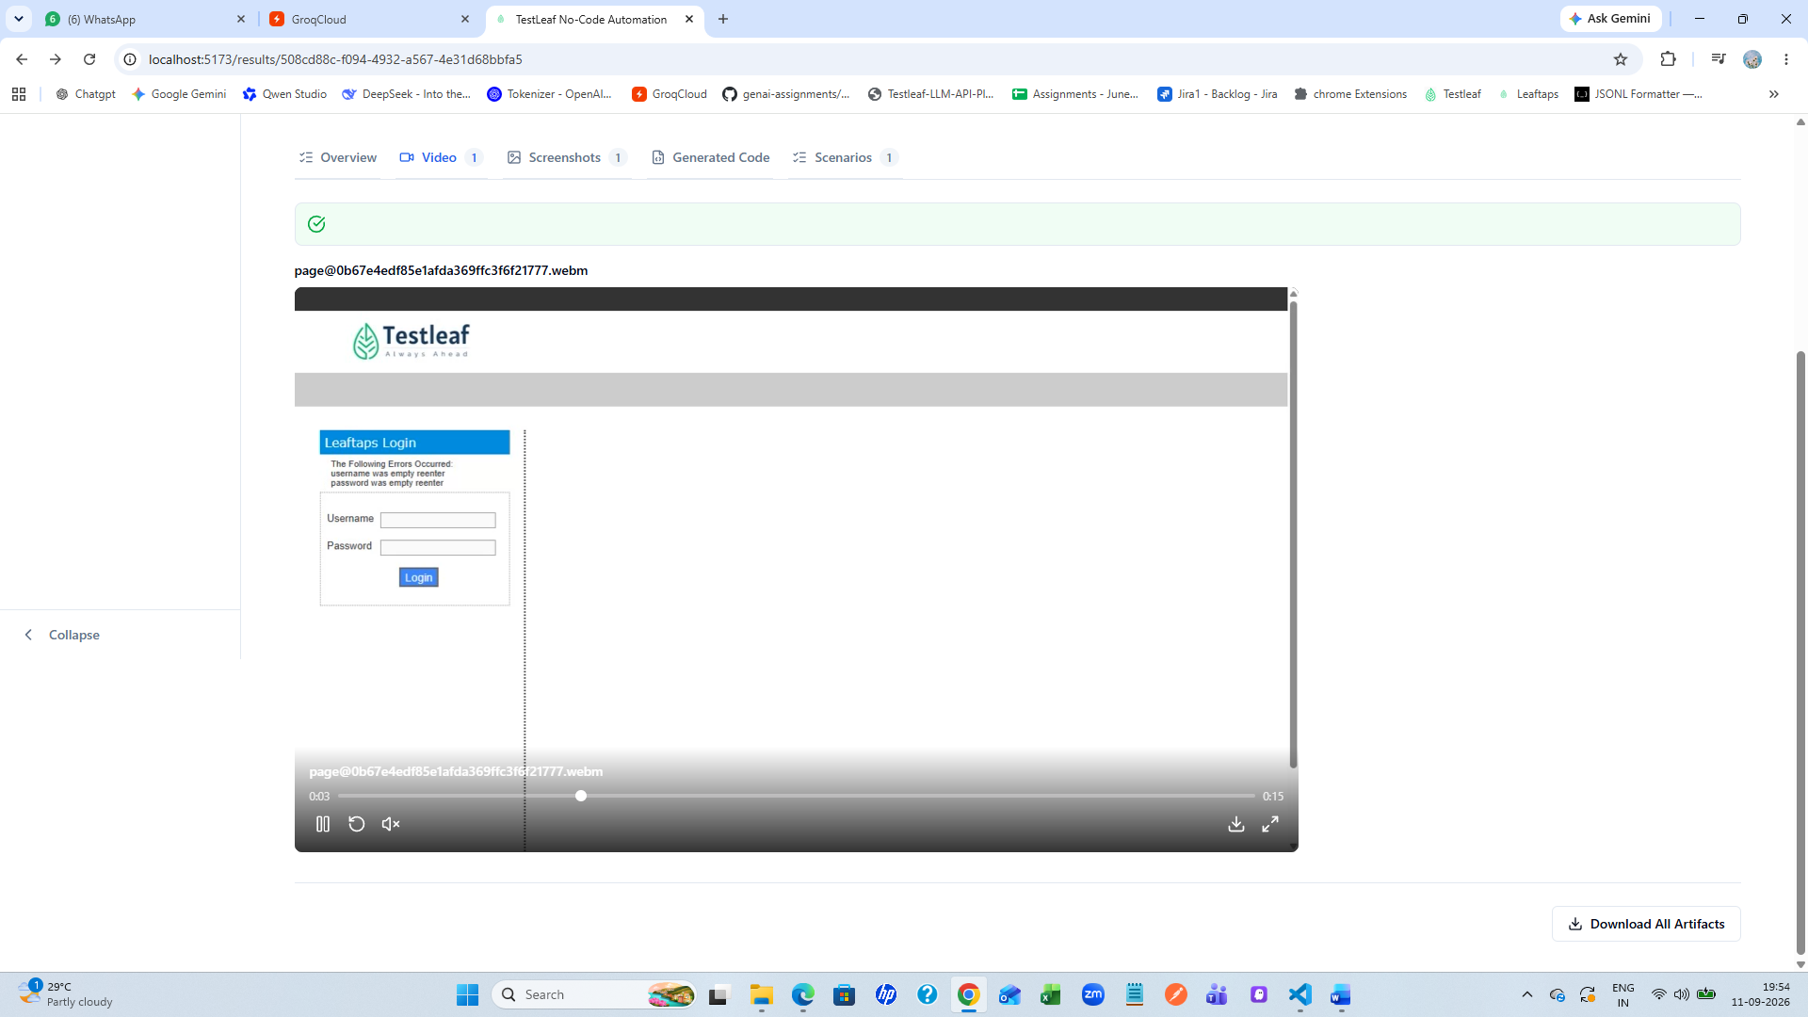
Screenshot
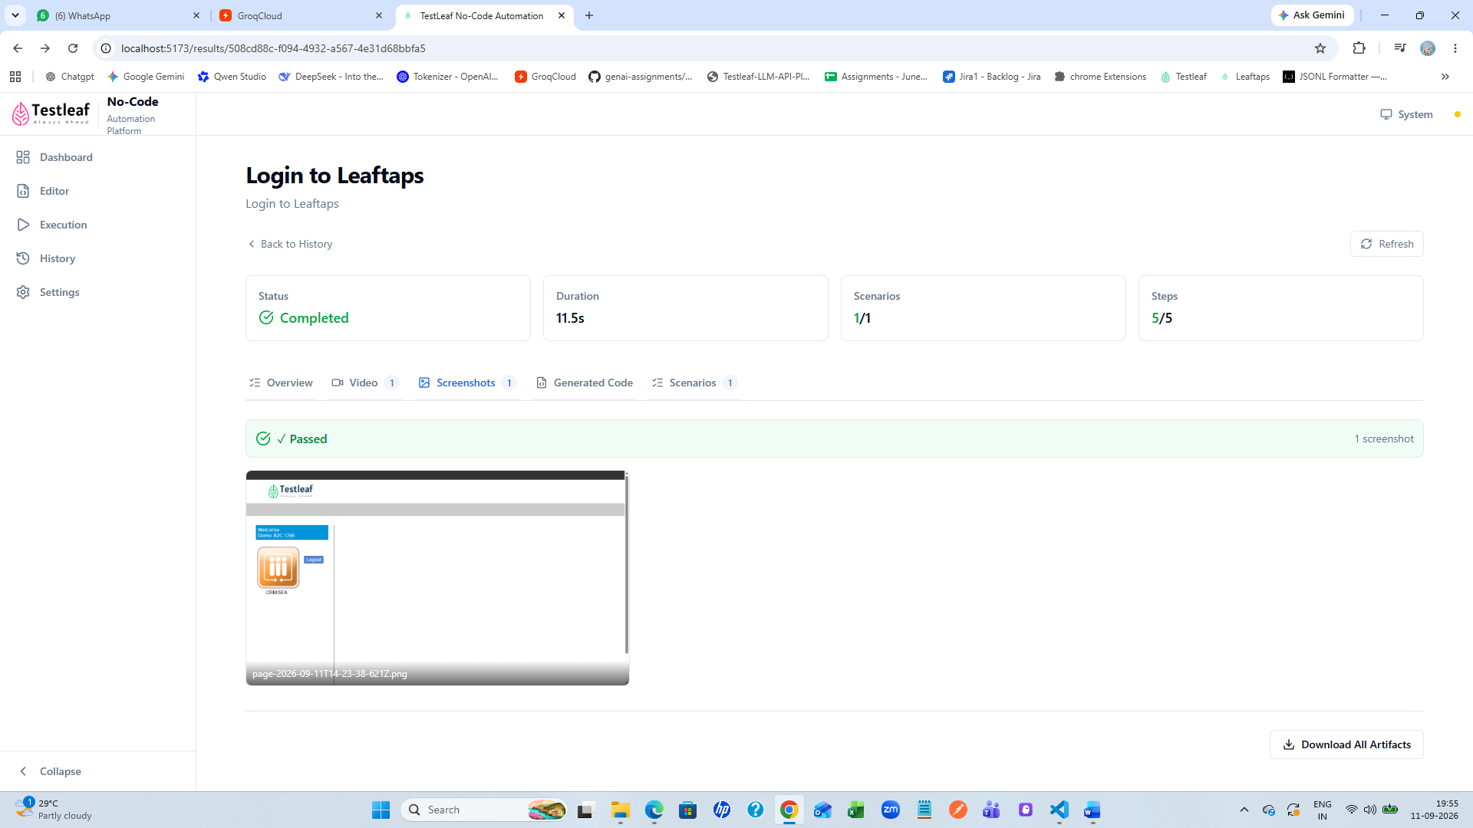
Dashboard
